Multi-Threading Assignment-1

1) Create and Run a Thread using Runnable Interface and Thread class and show usage of sleep and join methods in the created threads.

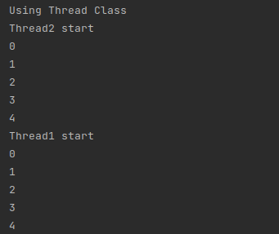

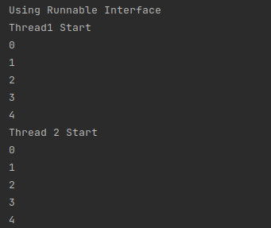

2) Use Synchronize method and synchronize block to enable synchronization between multiple threads trying to access method at same time.

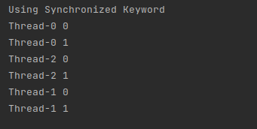

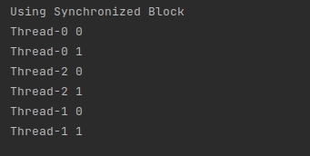

3) WAP to showcase the usage of volatile in java.

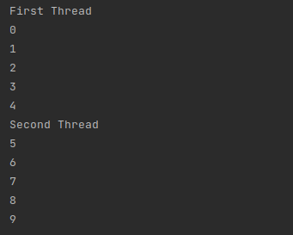

4) Write a code to simulate a deadlock in java

